Collected Data:-

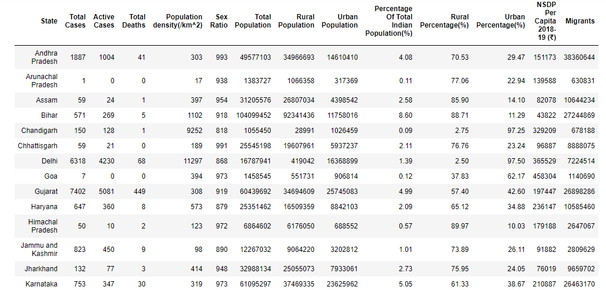
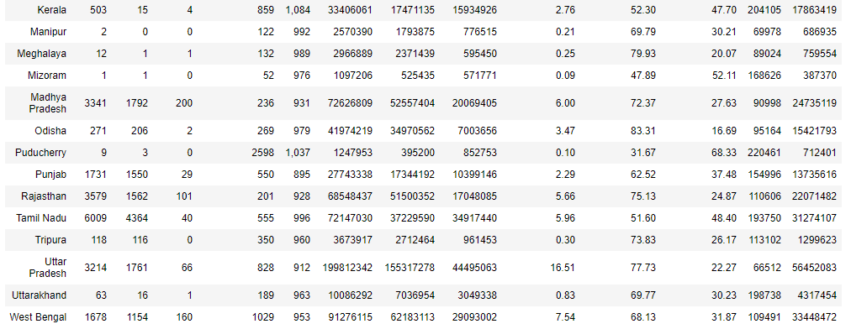

Data collected from the links mentioned in the bibliography.

The table provides the total covid cases ( Total Cases), details regarding the population distribution in each state, the per capita GDP and the total migrant population per state

ANALYSIS: -

The table below shows the correlation of the different factors but is difficult to analyse. Picking the specific factors that have a high correlation with the total cases, the next table was made.
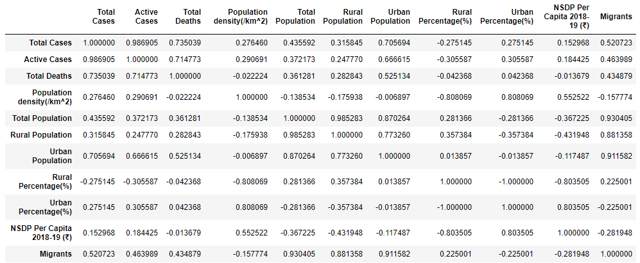

Strong correlation observed between number of cases of Covid19 and the total urban population
Moderately strong correlation observed between Migrant population and Total cases of Covid19
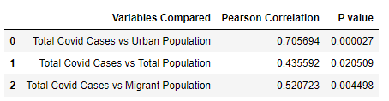

Regression between urban population and total cases shows strong linear relationship

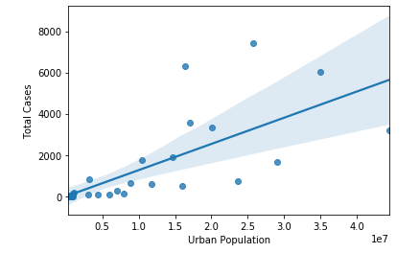

Regression between the migrant population and total covid19 cases shows a moderately strong linear relationship

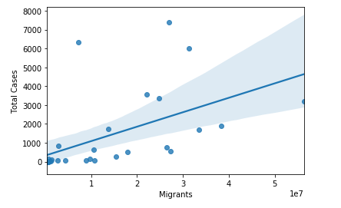

Since these two variables seem to show the greatest influence on the total cases from the parameters ive used for the analysis, the different states were ranked on the basis of the two factors where 0 indicates the state has the highest value for that factor. Using this, the states that have the highest value of both factors can be given additional importance which passing lockdown legislation.
(eg 5 states have a greater total population than tamil nadu but tamil nadu has a high value of urban population.)

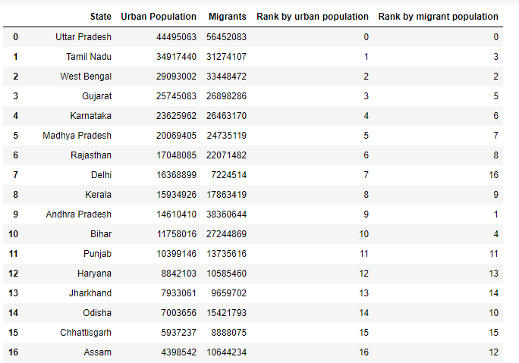

Bibliography:-
https://en.wikipedia.org/wiki/List_of_states_and_union_territories_of_India_by_population
https://en.wikipedia.org/wiki/List_of_Indian_states_and_union_territories_by_GDP_per_capita
https://www.mygov.in/covid-19/
https://censusindia.gov.in/2011census/d-series/d-2.html

